**CONTENTS:**

|  |  |
| --- | --- |
|  |  |
|  |  |
|  |  |
|  |  |
|  |  |
|  |  |
|  |  |
|  |  |

**INTRODUCTION:**

A database management system (DBMS) refers to the technology for creating and managing databases.

The main objective of this database project is to create a database to centrally handle a Database Management System based on FIFA Football World Cup Management. The database can provide various information about the teams or matters within the teams such as players or coaches of the World cup. Others matters such as matches, referee, stadium can be found also. This database consists of ten entities.

**SCENARIO DESCRIPTION:**

A FIFA Football World Cup management system contains Team. Team is uniquely identified by TEAM ID. Other attributes of a Team are TEAM NAME, RANK. A team has a Team_Stats. Team_Stats is also identified by TEAM ID Team_Stats has MATCH PLAYED, WIN, LOSS, DRAW. A Team plays many Matches. A Match is identified by MATCH ID. A Match also has TEAM 1 NAME, TEAM 2 NAME, WINNER, LOSSER, MATCH DATE, STADIUM ID, REFEREE ID. Many Matches are held in many Stadiums. A Stadium has unique STADIUM ID. Stadium also has STADIUM NAME, LOCATION, TOTAL MATCHES, CAPACITY. One Match is maintained by one Referee. Referee has unique REFEREE ID as primary key. Referee also has REFEREE NAME, AGE, N/O MATCHES, COUNTRY. One Team is maintained by one Coach. Coach is identified by COACH ID. Coach also has TEAM ID and COACH NAME. One Team contains many players. Player is identified by unique PLAYER ID. Player also has PLAYER NAME, TEAM ID, AGE and JERSEY NUMBER. A team also is captained by one Captain. Captain is identified by PLAYER ID. Captain also has TEAM ID, Y/O CAPTAINCY. One Player has one Player Stats. Player Stats is also identified by PLAYER ID. Player_Stats also has TEAM ID, GOALS, ASSIST, MATCH PLAYED, FOUL. A Player can be specialized in many Player Speciality. Player Speciality is also identified by PLAYER ID. Player Speciality also has POSITION and SKILL.

**ER DIAGARM ON SCENARIO:**

BEFORE NORMALIZATION:

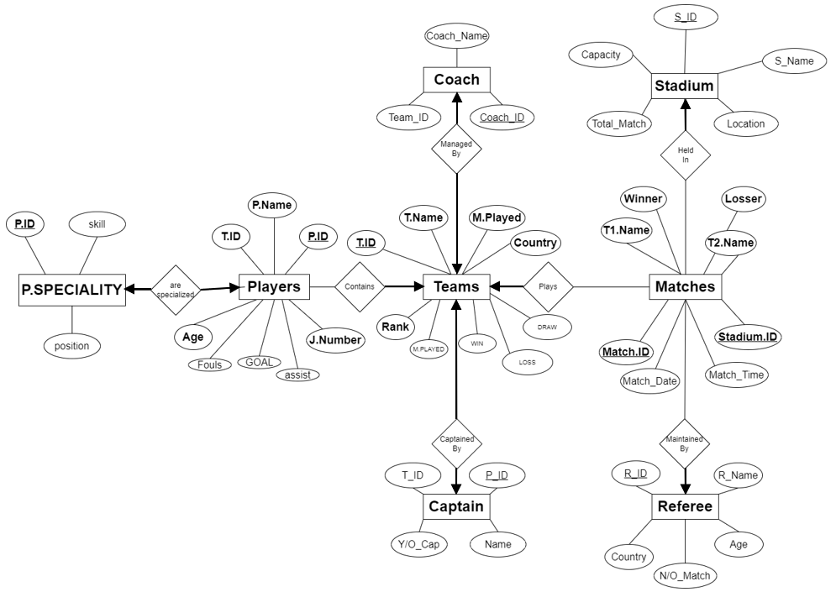

AFTER NORMALIZATION:

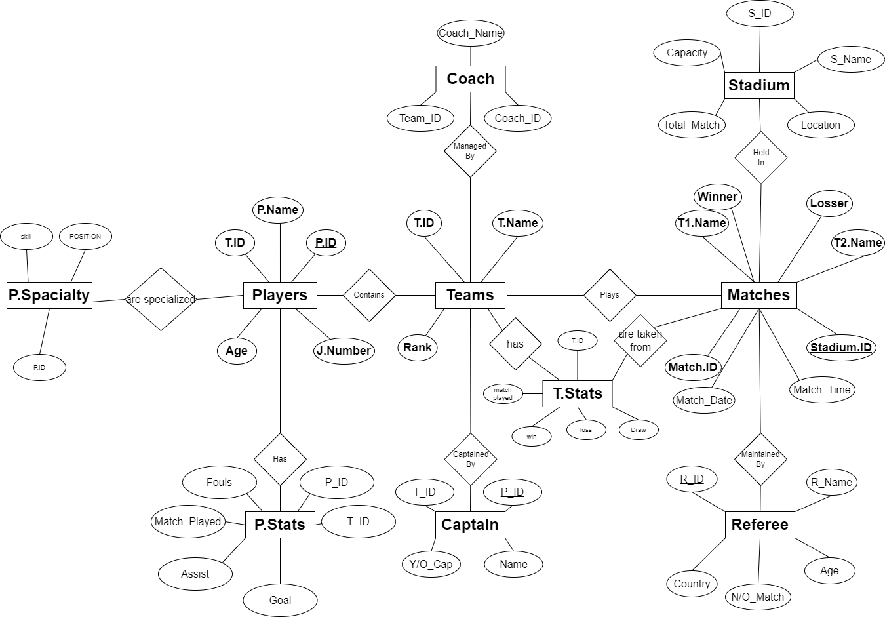

**NORMALIZATION:**

**1NF** (done on Player Speciality table):

Before 1NF:

|  |  |  |
| --- | --- | --- |
| PLAYER_ID | POSITION | SKILL |
| PORP01 | LEFT WING, STRIKER | GOAL MAKER, GOAL MACHINE |
| ARGP01 | RIGHT WING, CENTRE MIDFIELD | PLAY MAKER, GREAT PASS |
| GERPO3 | CENTRE MIDFIELD, STRIKER | GREAT PASS, SHOOT |
| FRAP01 | STRIKER | SCORER |
| BRAPO1 | LEFTWING, MIDFIELD | DRIBBLING, PLAYMAKER |

After 1NF:

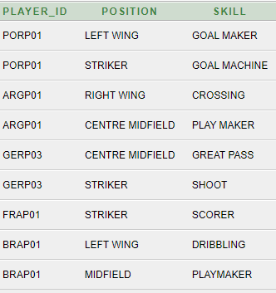

**2NF** (done on Player table and team table):

**Player Table:**

Before 2NF:

|  |  |  |  |  |  |  |  |  |
| --- | --- | --- | --- | --- | --- | --- | --- | --- |
| PLAYER  _ID | TEAM_ID | PLAYER_  NAME | AGE | MATCH  _PLAYED | GOALS | ASSIST | FOULS | JERSEY NUMBER |
| ARGP01 | ARG01 | MESSI | 35 | 4 | 5 | 2 | 1 | 10 |
| ARGP02 | ARG01 | DI MARIA | 34 | 4 | 2 | 3 | 2 | 11 |
| ARGP03 | ARG01 | DE PAUL | 24 | 4 | 1 | 5 | 3 | 7 |
| ARGP04 | ARG01 | EMI | 30 | 5 | 0 | 2 | 1 | 1 |
| GERP01 | GER01 | MUSIALA | 19 | 4 | 6 | 1 | 0 | 14 |
| GERP02 | GER01 | HERVERTZ | 23 | 4 | 3 | 2 | 4 | 11 |
| GERP03 | GER01 | MULLER | 34 | 6 | 2 | 5 | 2 | 13 |
| BRAP01 | BRA01 | NEYMER | 30 | 4 | 7 | 2 | 1 | 10 |

AFTER 2 NF:

**PLAYER TABLE:**

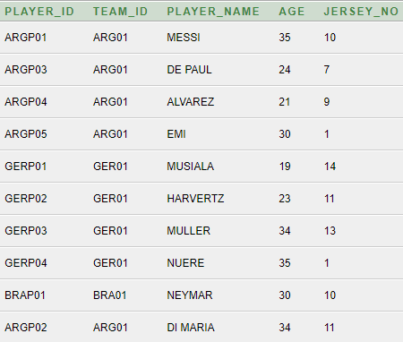

**PLAYER_STATS TABLE:**

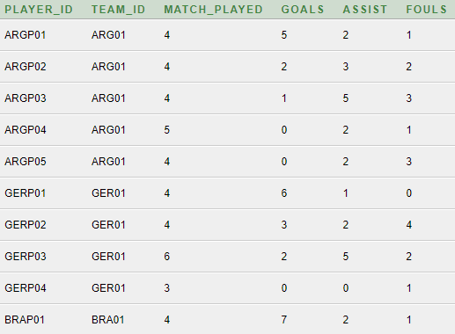

**Table Team before 2NF:**

|  |  |  |  |  |  |  |
| --- | --- | --- | --- | --- | --- | --- |
| TEAM_  ID | TEAM_NAME | RANK | MATCH_PLAYED | WINS | LOSS | DRAW |
| ARG01 | ARGENTINA | 1 | 4 | 3 | 0 | 1 |
| BRA01 | BRAZIL | 3 | 4 | 2 | 1 | 1 |
| GER01 | GERMANY | 2 | 4 | 2 | 1 | 1 |
| POR01 | PORTUGAL | 5 | 4 | 0 | 3 | 1 |
| FRA01 | FRANCE | 4 | 4 | 0 | 3 | 1 |

After 2NF:

**Table TEAM:** **Table TEAM_STATS:**

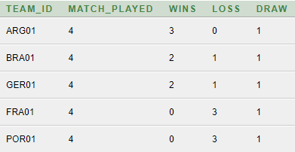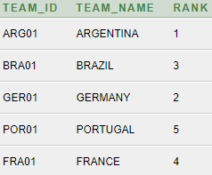

3NF:

3NF is not required on the database as:

* The database does not have any Transitive Dependency.
* No data duplication.
* No data anomalies.

**TABLE CREATION:**

**TEAM:**

create table TEAM(

TEAM_ID varchar(10) primary key,

TEAM_NAME varchar(20),

RANK number(3)

);

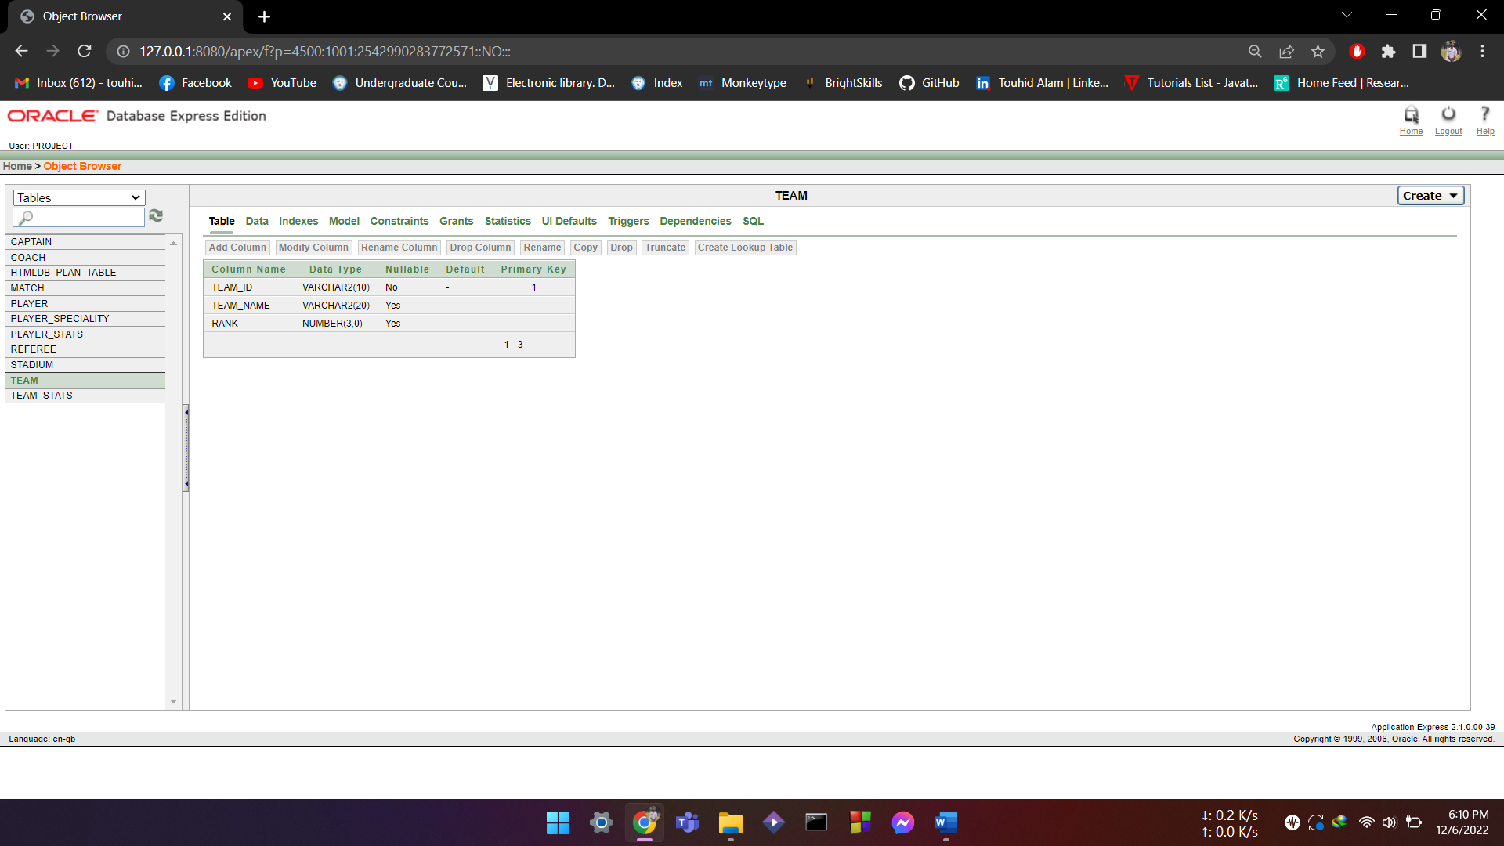

**TEAM_STATS:**

create table TEAM_STATS(

TEAM_ID references TEAM,

MATCH_PLAYED number(2),

WINS number(2),

LOSS number (2),

DRAW number(2)

);

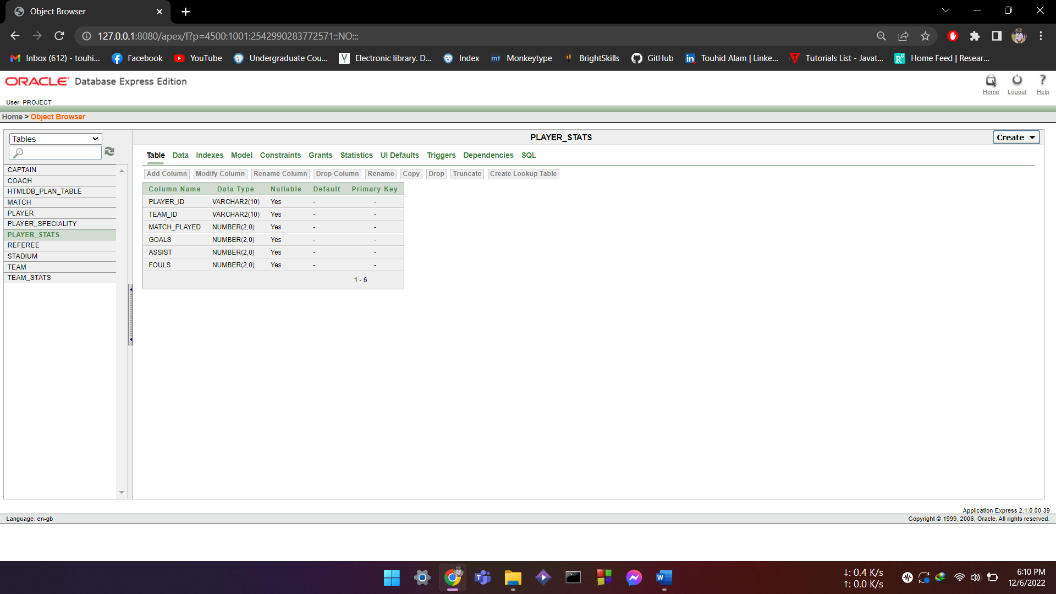

**MATCH:**

CREATE TABLE MATCH(

MATCH_ID VARCHAR(20) PRIMARY KEY,

TEAM1_NAME VARCHAR(20),

TEAM2_NAME VARCHAR(20),

WINNER VARCHAR(20),

LOSSER VARCHAR(20),

MATCH_DATE DATE,

STADIUM_ID REFERENCES STADIUM,

REFEREE_ID REFERENCES REFEREE

);

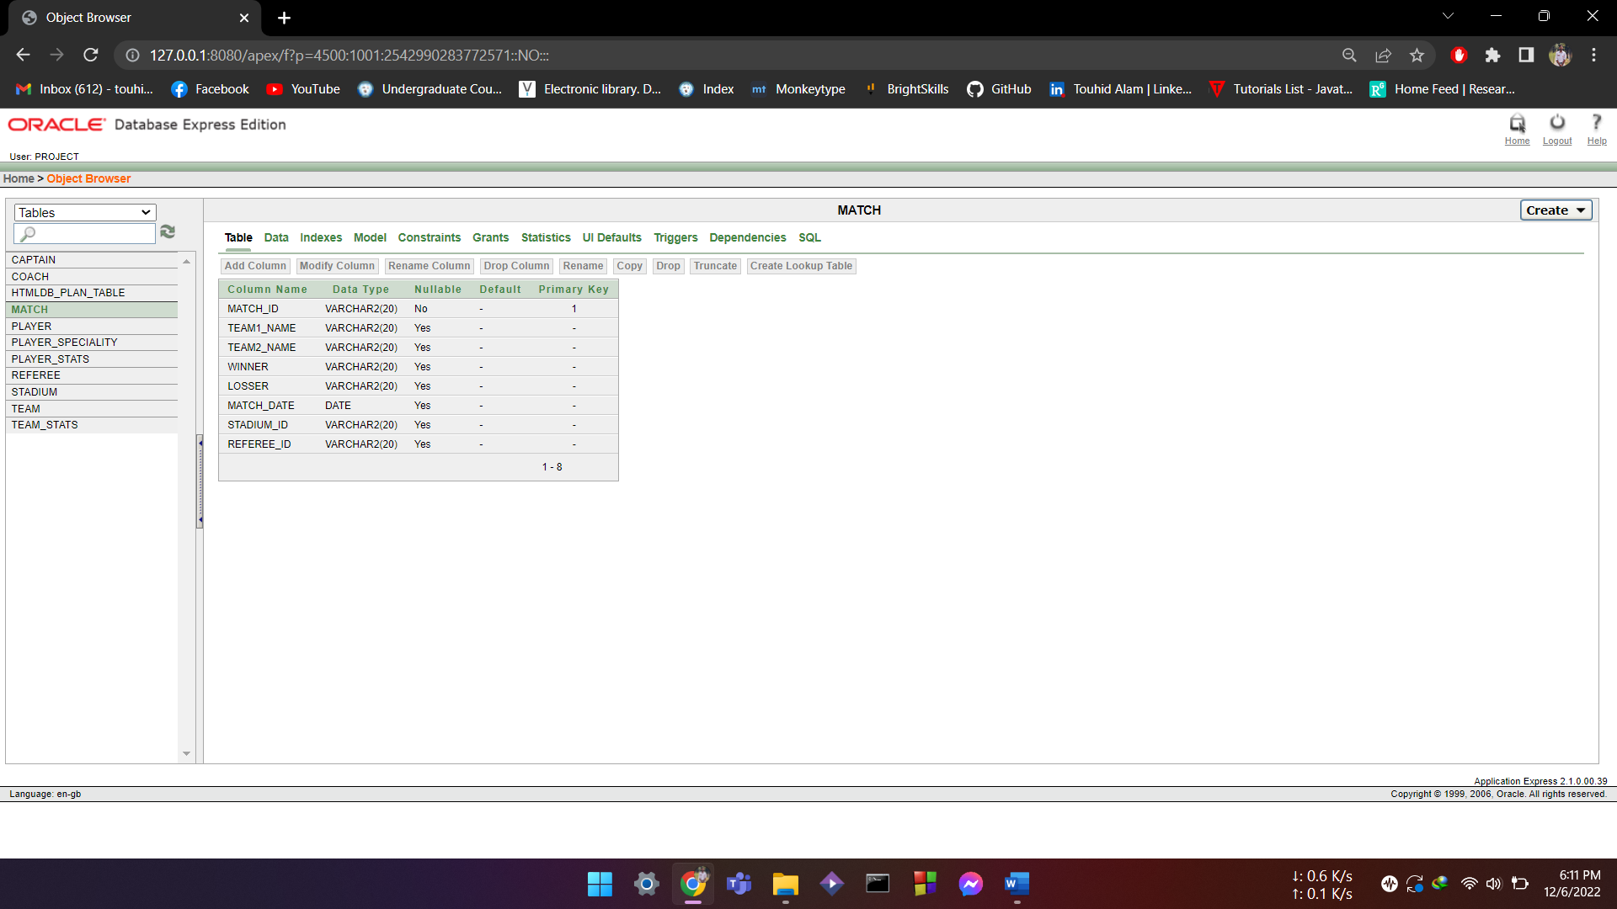

**REFREE:**

create table REFEREE(

REFEREE_ID varchar(20) primary key,

REFEREE_NAME varchar(20),

AGE number(3),

COUNTRY varchar(20),

TOTAL_MATCH number(3));



**STADIUM:**

create table STADIUM(

STADIUM_ID varchar(20) primary key,

STADIUM_NAME varchar(20),

CAPACITY number(6),

LOCATION varchar(30),

TOTAL_MATCHES number(2)

);

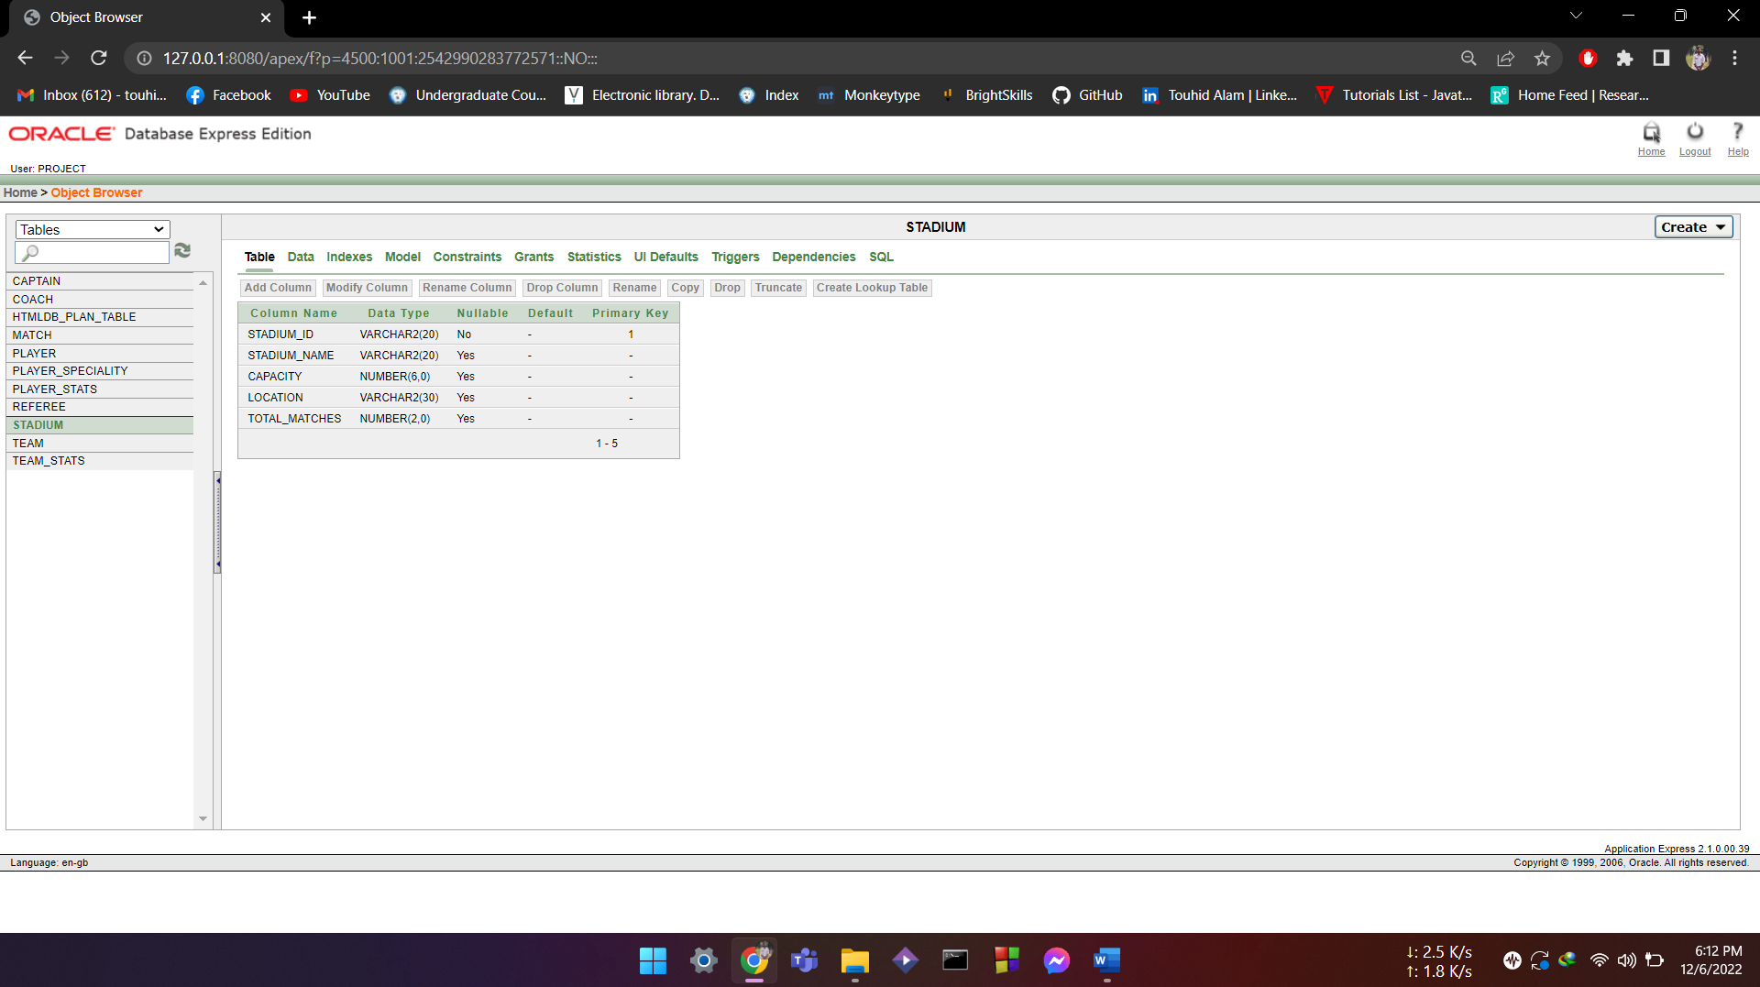

**COACH:**

create table COACH(

COACH_ID varchar(20) primary key,

COACH_NAME varchar(20),

AGE number(2),

TEAM_ID references TEAM

);

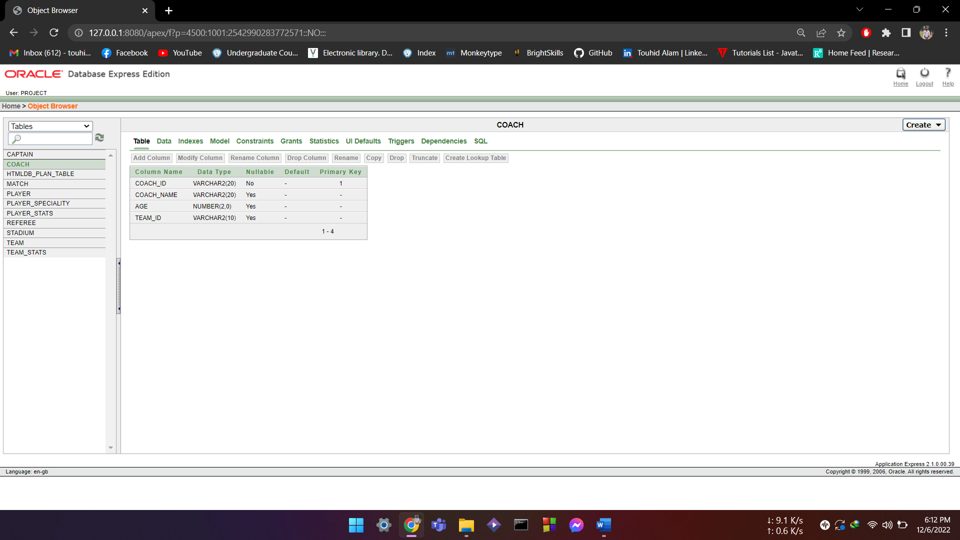

**PLAYER:**

create table PLAYER(

PLAYER_ID varchar(10) primary key,

TEAM_ID references TEAM,

PLAYER_NAME varchar(20),

AGE number(2),

JERSEY_NO number(2)

);

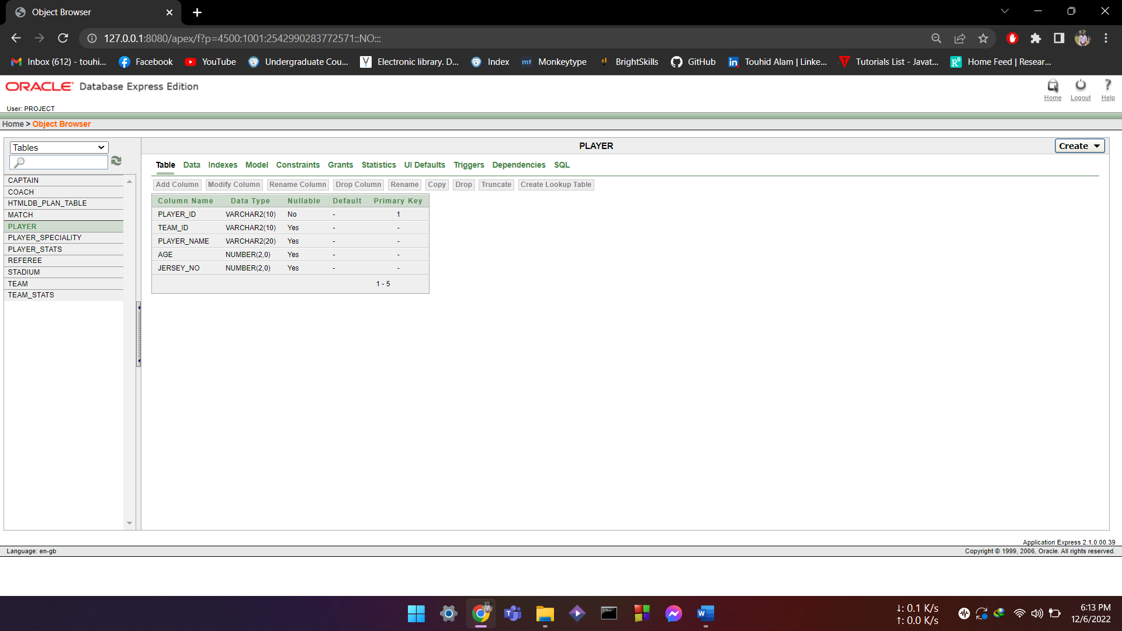

**CAPTION:**

create table CAPTAIN(

PLAYER_ID references PLAYER,

TEAM_ID references TEAM,

NAME varchar(20),

YEAR_OF_CAPTAINCY number(2));

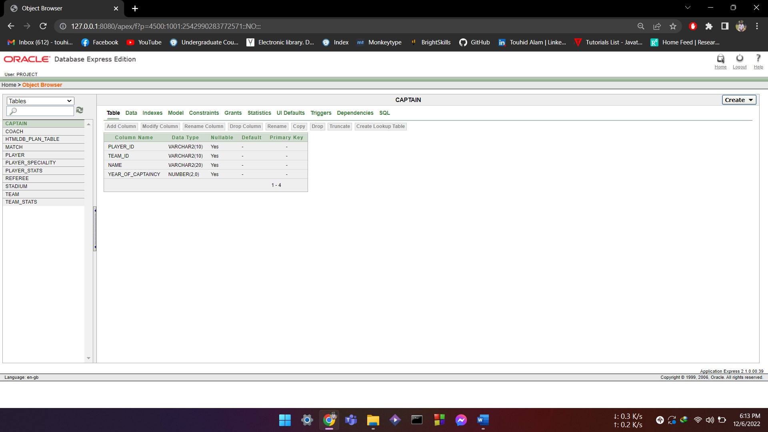

**PLAYER_STATS**:

create table PLAYER_STATS(

PLAYER_ID REFERENCES PLAYER,

TEAM_ID REFERENCES TEAM,

MATCH_PLAYED NUMBER(2),

GOALS NUMBER(2),

ASSIST NUMBER(2),

FOULS NUMBER(2)

)

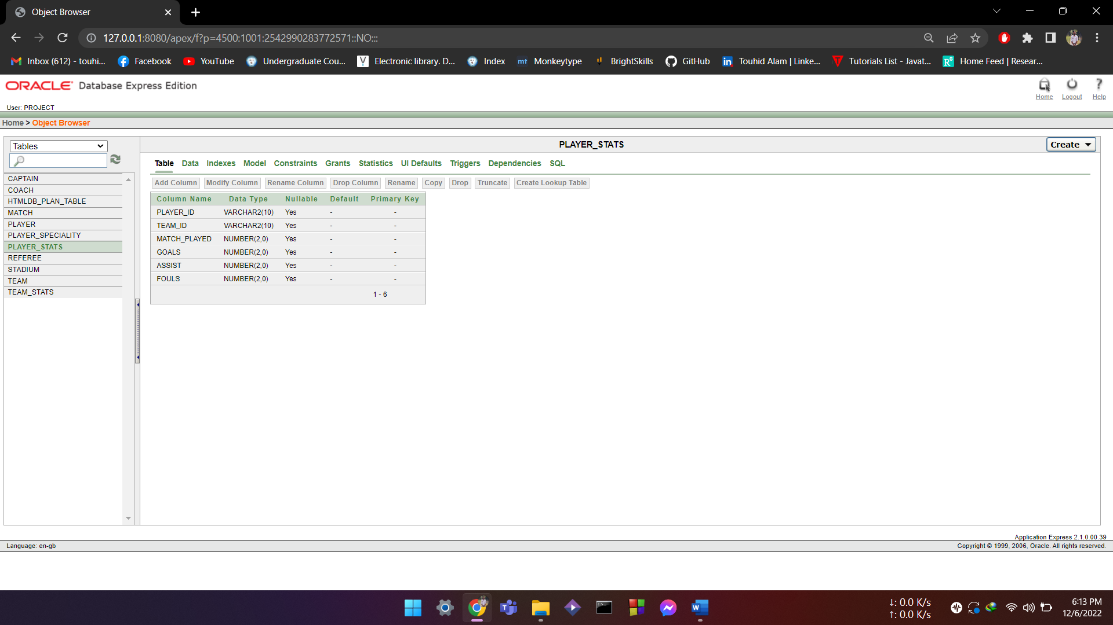

**PLAYER_SPECIALITY:**

CREATE TABLE PLAYER_SPECIALITY(

PLAYER_ID REFERENCES PLAYER,

POSITION VARCHAR(20),

SKILL VARCHAR(20)

);

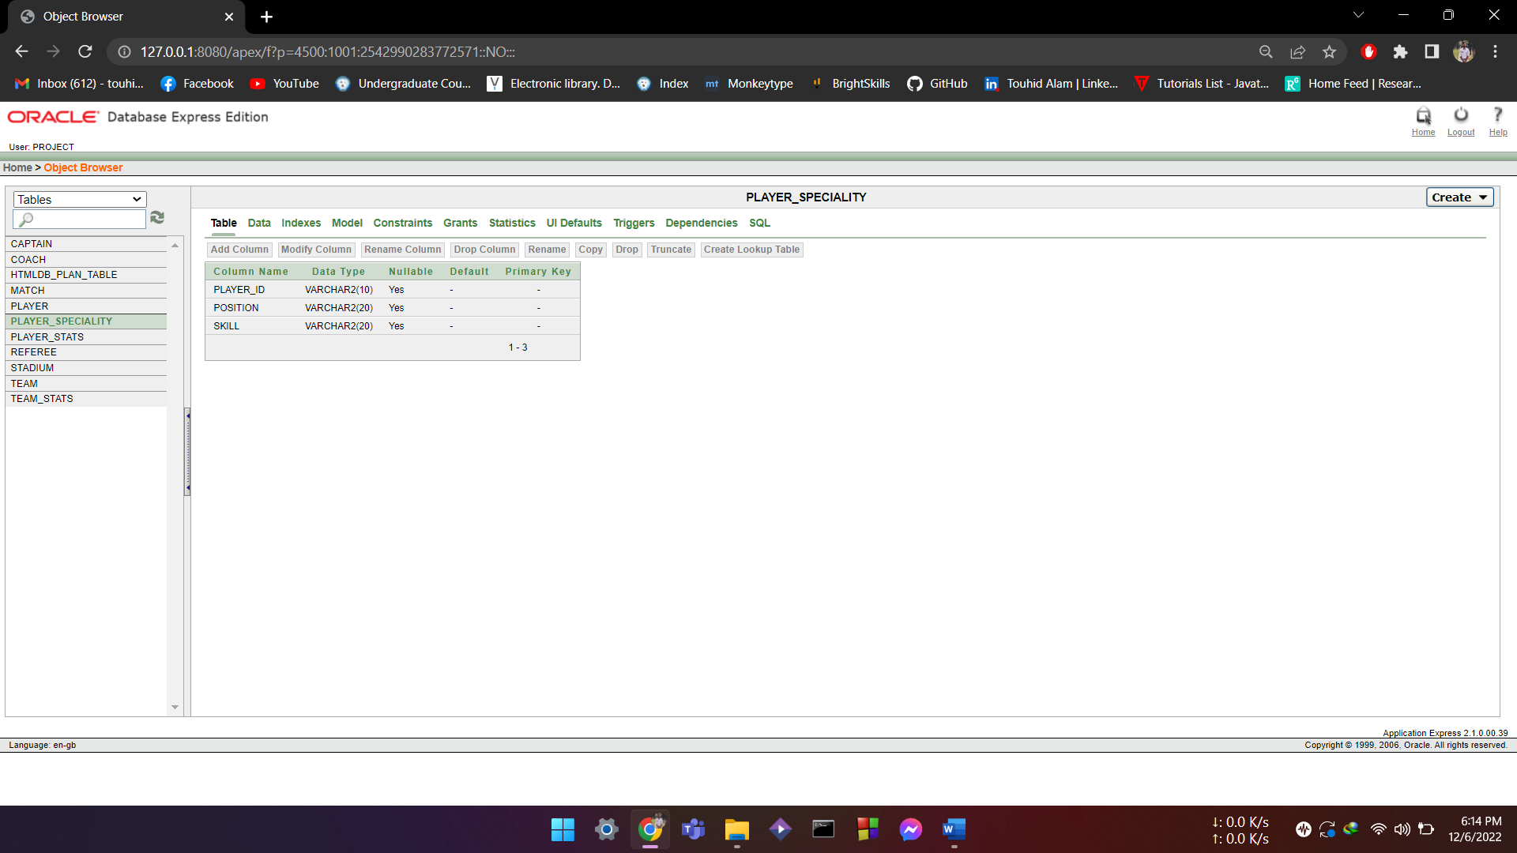

**DATA INSERTION:**

**INSERT INTO TEAM:**

INSERT INTO TEAM VALUES(

'BRA01','BRAZIL',3);

INSERT INTO TEAM VALUES(

'ARG01','ARGENTINA',1);

INSERT INTO TEAM VALUES(

'GER01','GERMANY',2);

INSERT INTO TEAM VALUES(

'POR01','PORTUGAL',5);

INSERT INTO TEAM VALUES(

'FRA01','FRANCE',4);

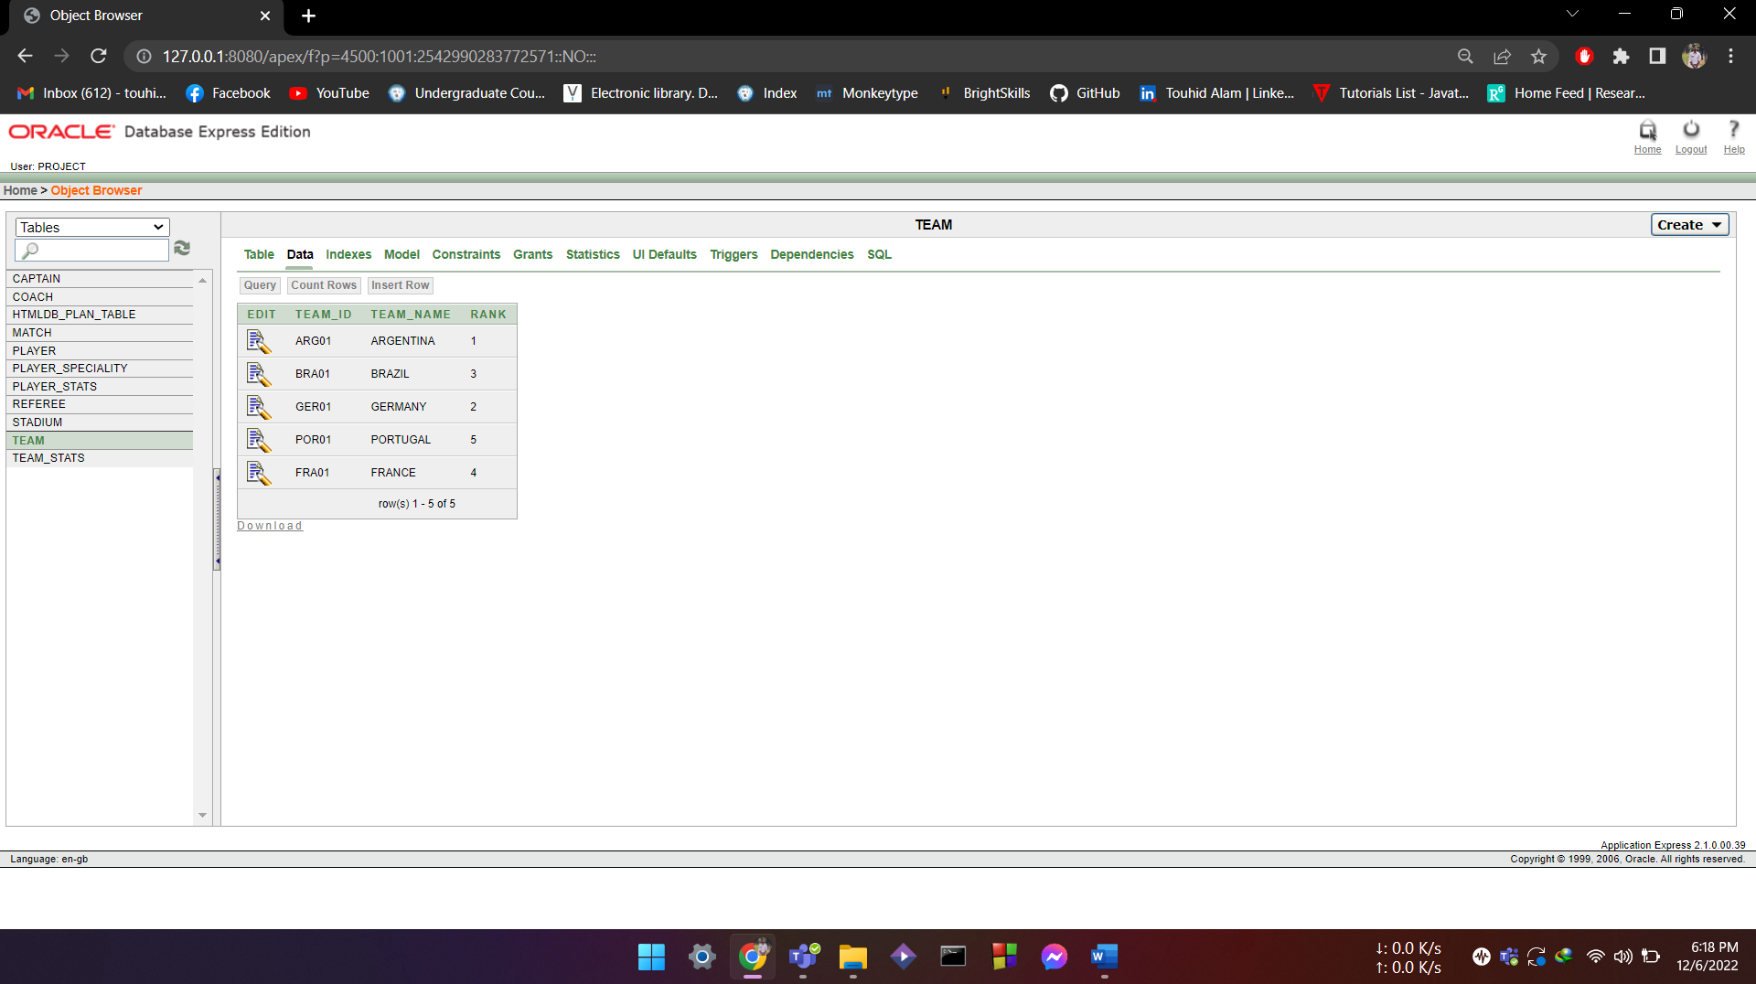

**INSERT INTO TEAM_STATS:**

insert into TEAM_STATS VALUES(

'ARG01',4,3,0,1);

insert into TEAM_STATS VALUES(

'BRA01',4,2,1,1);

insert into TEAM_STATS VALUES(

'GER01',4,2,1,1);

insert into TEAM_STATS VALUES(

'FRA01',4,0,3,1);

insert into TEAM_STATS VALUES(

'POR01',4,0,3,1);

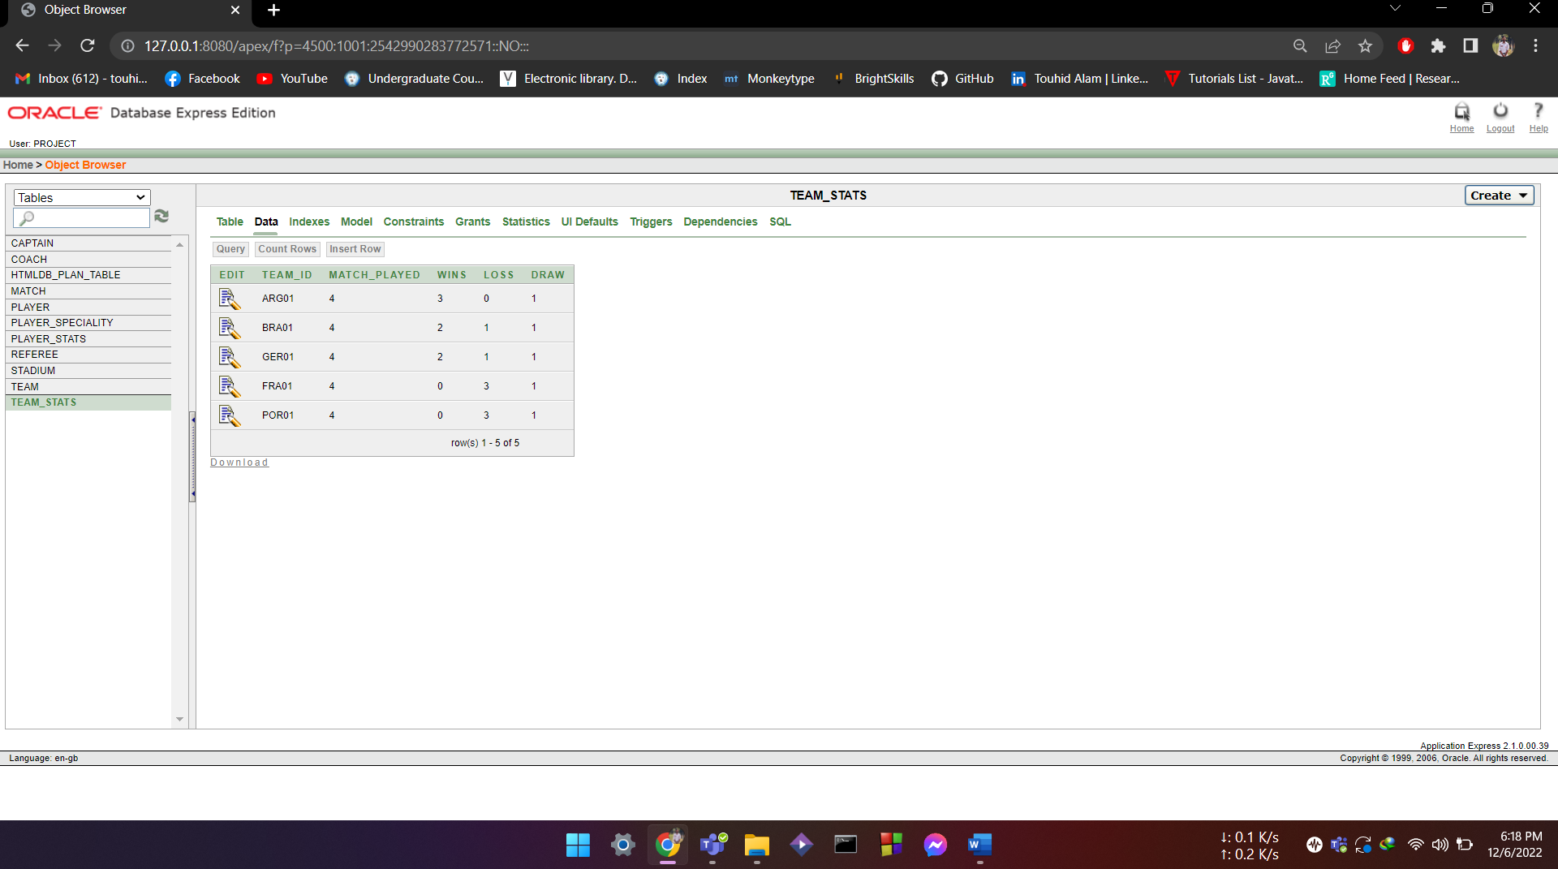

**INSERT INTO REFEREE:**

INSERT INTO REFEREE VALUES(

'REF01','MARK',45,'SPAIN',23);

INSERT INTO REFEREE VALUES(

'REF02','COLLINA',54,'ITALY',54);

INSERT INTO REFEREE VALUES(

'REF03','WEBB',61,'SPAIN',58);

INSERT INTO REFEREE VALUES(

'REF04','PUHL',39,'PORTUGAL',17)

INSERT INTO REFEREE VALUES(

'REF05','LUKA',59,'ENGLAND',12);

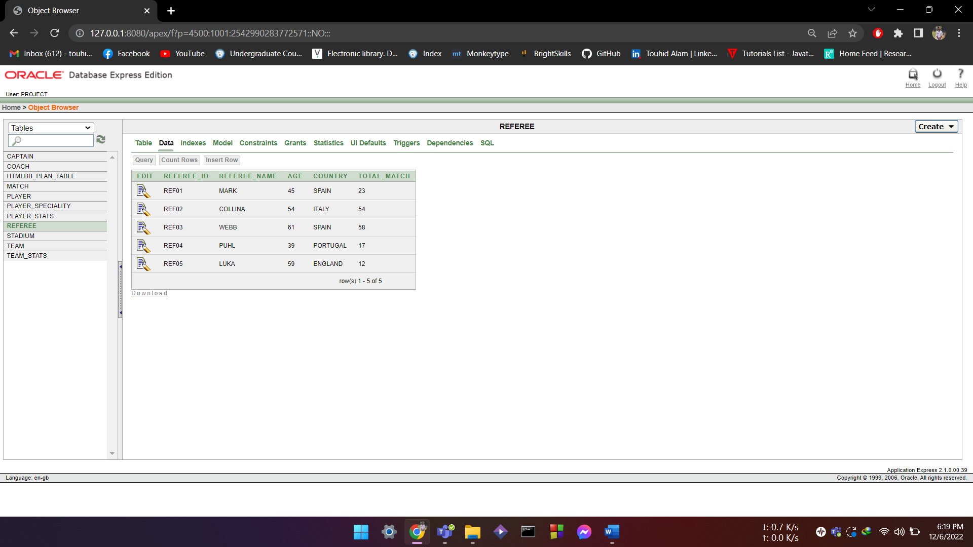

**INSERT INTO STADIUM:**

INSERT INTO STADIUM VALUES

('STD01','ALLINAZ ARENA',90000,'BAYERN',67);

INSERT INTO STADIUM VALUES

('STD02','SIGNAL IDUNA',70000,'BOROSSIA',54);

INSERT INTO STADIUM VALUES

('STD03','WESTFAL',85000,'BERLIN',78);

INSERT INTO STADIUM VALUES

('STD04','VELTINS',60000,'BERLIN',45);

INSERT INTO STADIUM VALUES

('STD05','PARK STADIUM',72000,'MUNICH',65);

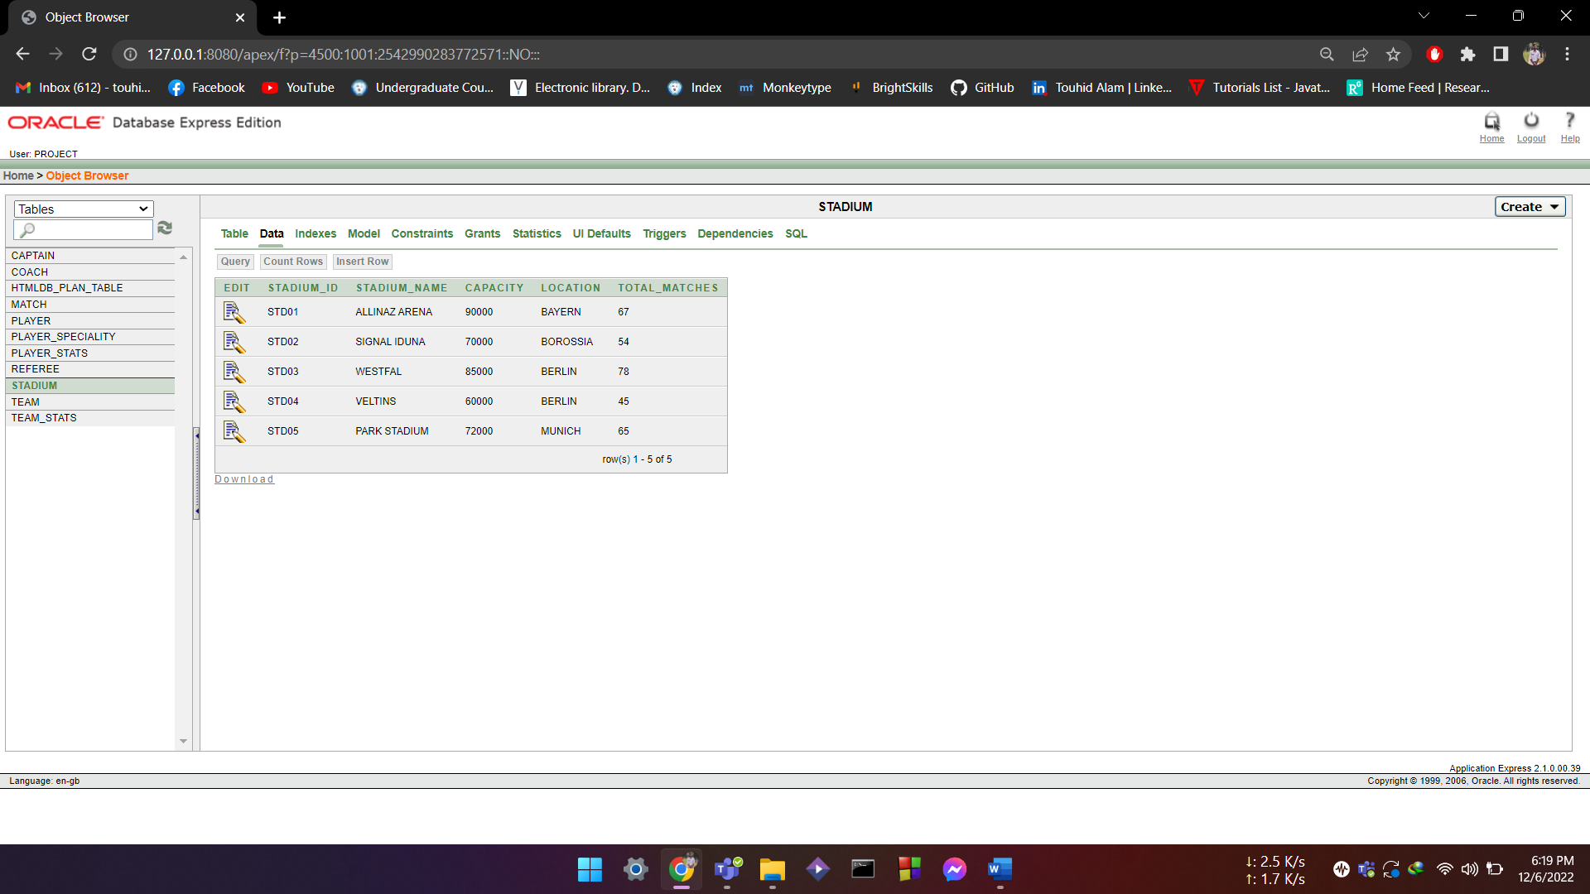

**INSERT INTO COACH:**

INSERT INTO COACH VALUES(

'GERC01','FLICK',57,'GER01');

INSERT INTO COACH VALUES(

'ARGC01','SCOLANI',41,'ARG01');

INSERT INTO COACH VALUES(

'BRAC01','TITE',62,'BRA01');

INSERT INTO COACH VALUES(

'PORC01','PELIPE',55,'POR01');

INSERT INTO COACH VALUES(

'FRAC01','DIDIER',54,'FRA01');

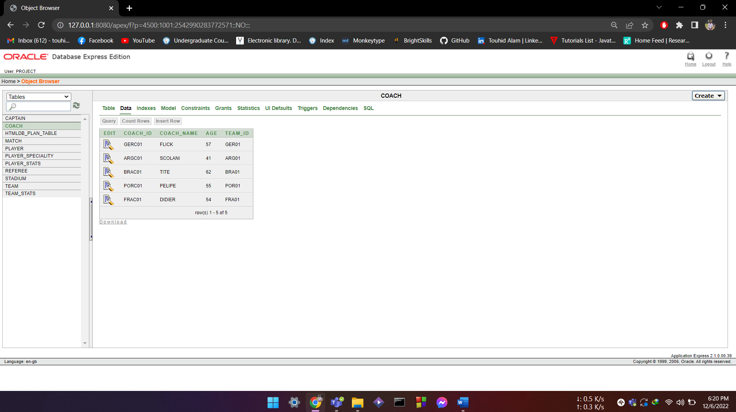

**INSERT INTO PLAYER:**

INSERT INTO PLAYER VALUES(

'ARGP01','ARG01','MESSI',35,10);

INSERT INTO PLAYER VALUES(

'ARGP02','ARG01','DI MARIA',34,11);

INSERT INTO PLAYER VALUES(

'ARGP03','ARG01','DE PAUL',24,7);

INSERT INTO PLAYER VALUES(

'ARGP04','ARG01','ALVAREZ',21,9);

INSERT INTO PLAYER VALUES(

'ARGP05','ARG01','EMI',30,1);

INSERT INTO PLAYER VALUES(

'GERP01','GER01','MUSIALA',19,14);

INSERT INTO PLAYER VALUES(

'GERP02','GER01','HARVERTZ',23,11);

INSERT INTO PLAYER VALUES(

'GERP03','GER01','MULLER',34,13);

INSERT INTO PLAYER VALUES(

'GERP04','GER01','NUERE',35,1);

INSERT INTO PLAYER VALUES(

'BRAP01','BRA01','NEYMAR',30,10);

INSERT INTO PLAYER VALUES(

'BRAP02','BRA01','RODREYGO',20,11);

INSERT INTO PLAYER VALUES(

'BRAP03','BRA01','VINI',19,18);

INSERT INTO PLAYER VALUES(

'BRAP04','BRA01','BECKER',29,01);

INSERT INTO PLAYER VALUES(

'FRAP01','FRA01','MBAPPE',21,10);

INSERT INTO PLAYER VALUES(

'FRAP02','FRA01','GIROUD',28,9);

INSERT INTO PLAYER VALUES(

'FRAP03','FRA01','KANTE',26,6);

INSERT INTO PLAYER VALUES(

'FRAP04','FRA01','LLORIS',32,1);

INSERT INTO PLAYER VALUES(

'PORP01','POR01','RONALDO',37,7);

INSERT INTO PLAYER VALUES(

'PORP02','POR01','BRUNO',24,8);

INSERT INTO PLAYER VALUES(

'PORP03','POR01','MENDES',21,5);

INSERT INTO PLAYER VALUES(

'PORP04','POR01','COSTA',32,1);

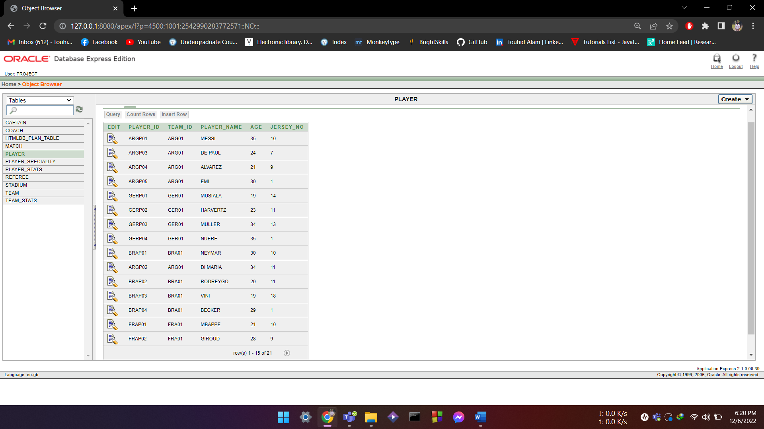

**INSERT CAPTAIN:**

INSERT INTO CAPTAIN VALUES(

'ARGP01','ARG01','MESSI',8);

INSERT INTO CAPTAIN VALUES(

'GERP03','GER01','MULLER',5);

INSERT INTO CAPTAIN VALUES(

'BRAP01','BRA01','NEYMAR',4);

INSERT INTO CAPTAIN VALUES(

'FRAP04','FRA01','LLORIS',6);

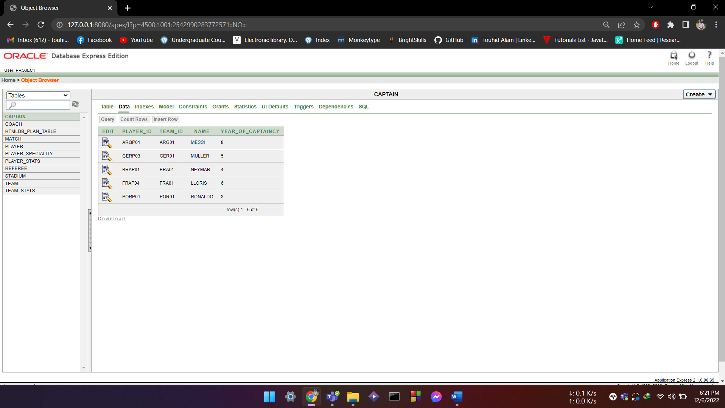

**INSERT PLAYER_STATS**

INSERT INTO PLAYER_STATS

into PLAYER_STATS VALUES(

'ARGP01','ARG01',04,05,02,01)

insert into PLAYER_STATS VALUES(

'ARGP02','ARG01',04,02,03,02)

insert into PLAYER_STATS VALUES(

'ARGP03','ARG01',04,01,05,03)

insert into PLAYER_STATS VALUES(

'ARGP04','ARG01',05,0,02,01)

insert into PLAYER_STATS VALUES(

'ARGP05','ARG01',04,0,02,03)

insert into PLAYER_STATS VALUES(

'GERP01','GER01',04,06,01,00)

insert into PLAYER_STATS VALUES(

'GERP02','GER01',04,03,02,04)

insert into PLAYER_STATS VALUES(

'GERP03','GER01',06,02,05,02);

insert into PLAYER_STATS VALUES(

'GERP04','GER01',03,00,00,01);

insert into PLAYER_STATS VALUES(

'BRAP01','BRA01',04,07,02,01);

insert into PLAYER_STATS VALUES(

'BRAP02','BRA01',04,02,04,04);

insert into PLAYER_STATS VALUES(

'BRAP03','BRA01',04,01,06,08);

insert into PLAYER_STATS VALUES(

'BRAP04','BRA01',02,00,01,01);

insert into PLAYER_STATS VALUES(

'FRAP01','FRA01',04,10,00,03);

insert into PLAYER_STATS VALUES(

'FRAP02','FRA01',04,2,05,07);

insert into PLAYER_STATS VALUES(

'FRAP03','FRA01',04,0,3,04);

insert into PLAYER_STATS VALUES(

'FRAP04','FRA01',05,0,0,00);

insert into PLAYER_STATS VALUES(

'PORP01','POR01',04,08,01,09);

insert into PLAYER_STATS VALUES(

'PORP02','POR01',03,00,06,02);

insert into PLAYER_STATS VALUES(

'PORP03','POR01',04,01,02,04);

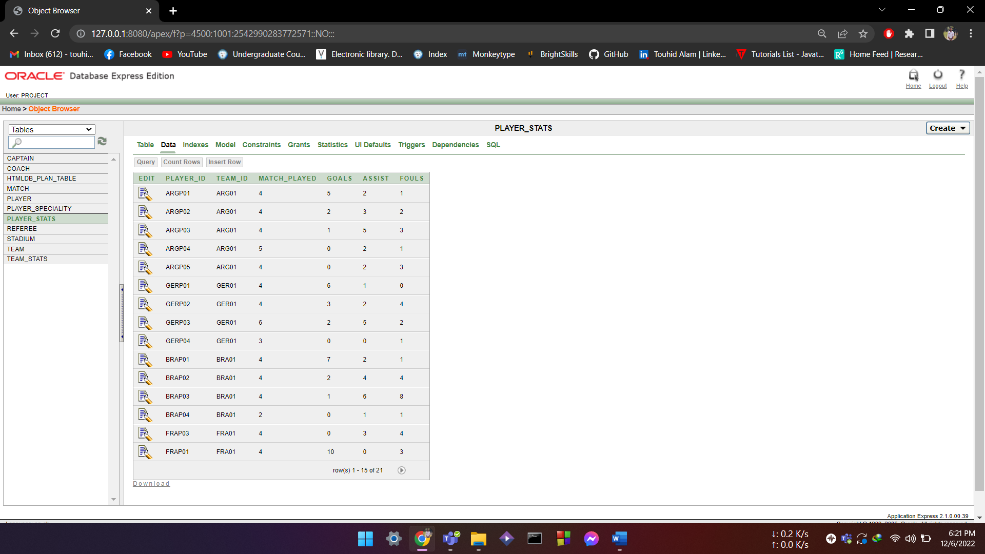

**INSERT PLAYER_SPECIALITY:**

INSERT INTO PLAYER_SPECIALITY VALUES(

'ARG01','RIGHT WING','CROSSING');

INSERT INTO PLAYER_SPECIALITY VALUES(

'ARGP01','CENTRE MIDFIELD','PLAY MAKER');

INSERT INTO PLAYER_SPECIALITY VALUES(

'GERP03','CENTRE MIDFIELD','GREAT PASS');

INSERT INTO PLAYER_SPECIALITY VALUES(

'GERP03','STRIKER','SHOOT');

INSERT INTO PLAYER_SPECIALITY VALUES(

'FRAP01','STRIKER','SCORER');

INSERT INTO PLAYER_SPECIALITY VALUES(

'BRAP01','LEFT WING','DRIBBLING');

INSERT INTO PLAYER_SPECIALITY VALUES(

'BRAP01','MIDFIELD','PLAYMAKER');

insert into PLAYER_SPECIALITY values(

'PORP01','LEFT WING','GOAL MAKER')

insert into PLAYER_SPECIALITY values(

'PORP01','STRIKER','GOAL MACHINE')

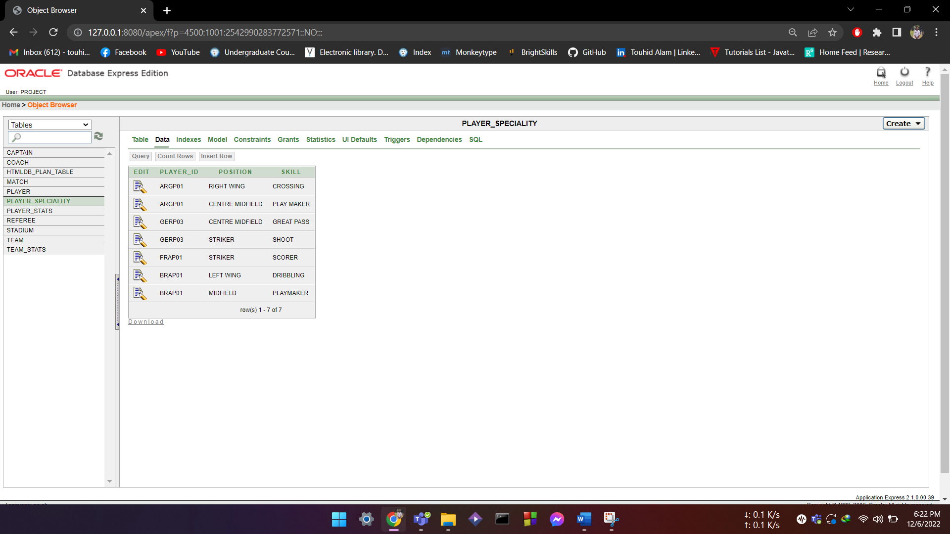

**INSERT MATCH:**

INSERT INTO MATCH VALUES(

'MTH01','ARGENTINA','BRAZIL','','',TO_DATE('01-12-2022','DD-MM-YYYY'),'STD01','REF01');

INSERT INTO MATCH VALUES(

'MTH02','FRANCE','PORTUGAL','','',TO_DATE('01-12-2022','DD-MM-YYYY'),'STD04','REF03');

INSERT INTO MATCH VALUES(

'MTH03','GERMANY','ARGENTINA','ARGENTINA','GERMANY',TO_DATE('03-12-2022','DD-MM-YYYY'),'STD02','REF05');

INSERT INTO MATCH VALUES(

'MTH04','BRAZIL','FRANCE','BRAZIL','FRANCE',TO_DATE('04-12-2022','DD-MM-YYYY'),'STD03','REF02');

INSERT INTO MATCH VALUES(

'MTH05','ARGENTINA','PORTUGAL','ARGENTINA','PORTUGAL',TO_DATE('05-12-2022','DD-MM-YYYY'),'STD05','REF04');

INSERT INTO MATCH VALUES(

'MTH06','GERMANY','FRANCE','GERMANY','FRANCE',TO_DATE('07-12-2022','DD-MM-YYYY'),'STD01','REF01');

INSERT INTO MATCH VALUES(

'MTH07','BRAZIL','PORTUGAL','BRAZIL','PORTUGAL',TO_DATE('08-12-2022','DD-MM-YYYY'),'STD02','REF04');

INSERT INTO MATCH VALUES(

'MTH08','GERMANY','BRAZIL','','',TO_DATE('10-12-2022','DD-MM-YYYY'),'STD05','REF05');

INSERT INTO MATCH VALUES(

'MTH09','ARGENTINA','FRANCE','ARGENTINA','FRANCE',TO_DATE('12-12-2022','DD-MM-YYYY'),'STD04','REF03');

INSERT INTO MATCH VALUES(

'MTH10','PORTUGAL','GERMANY','GERMANY','PORTUGAL',TO_DATE('13-12-2022','DD-MM-YYYY'),'STD03','REF02');

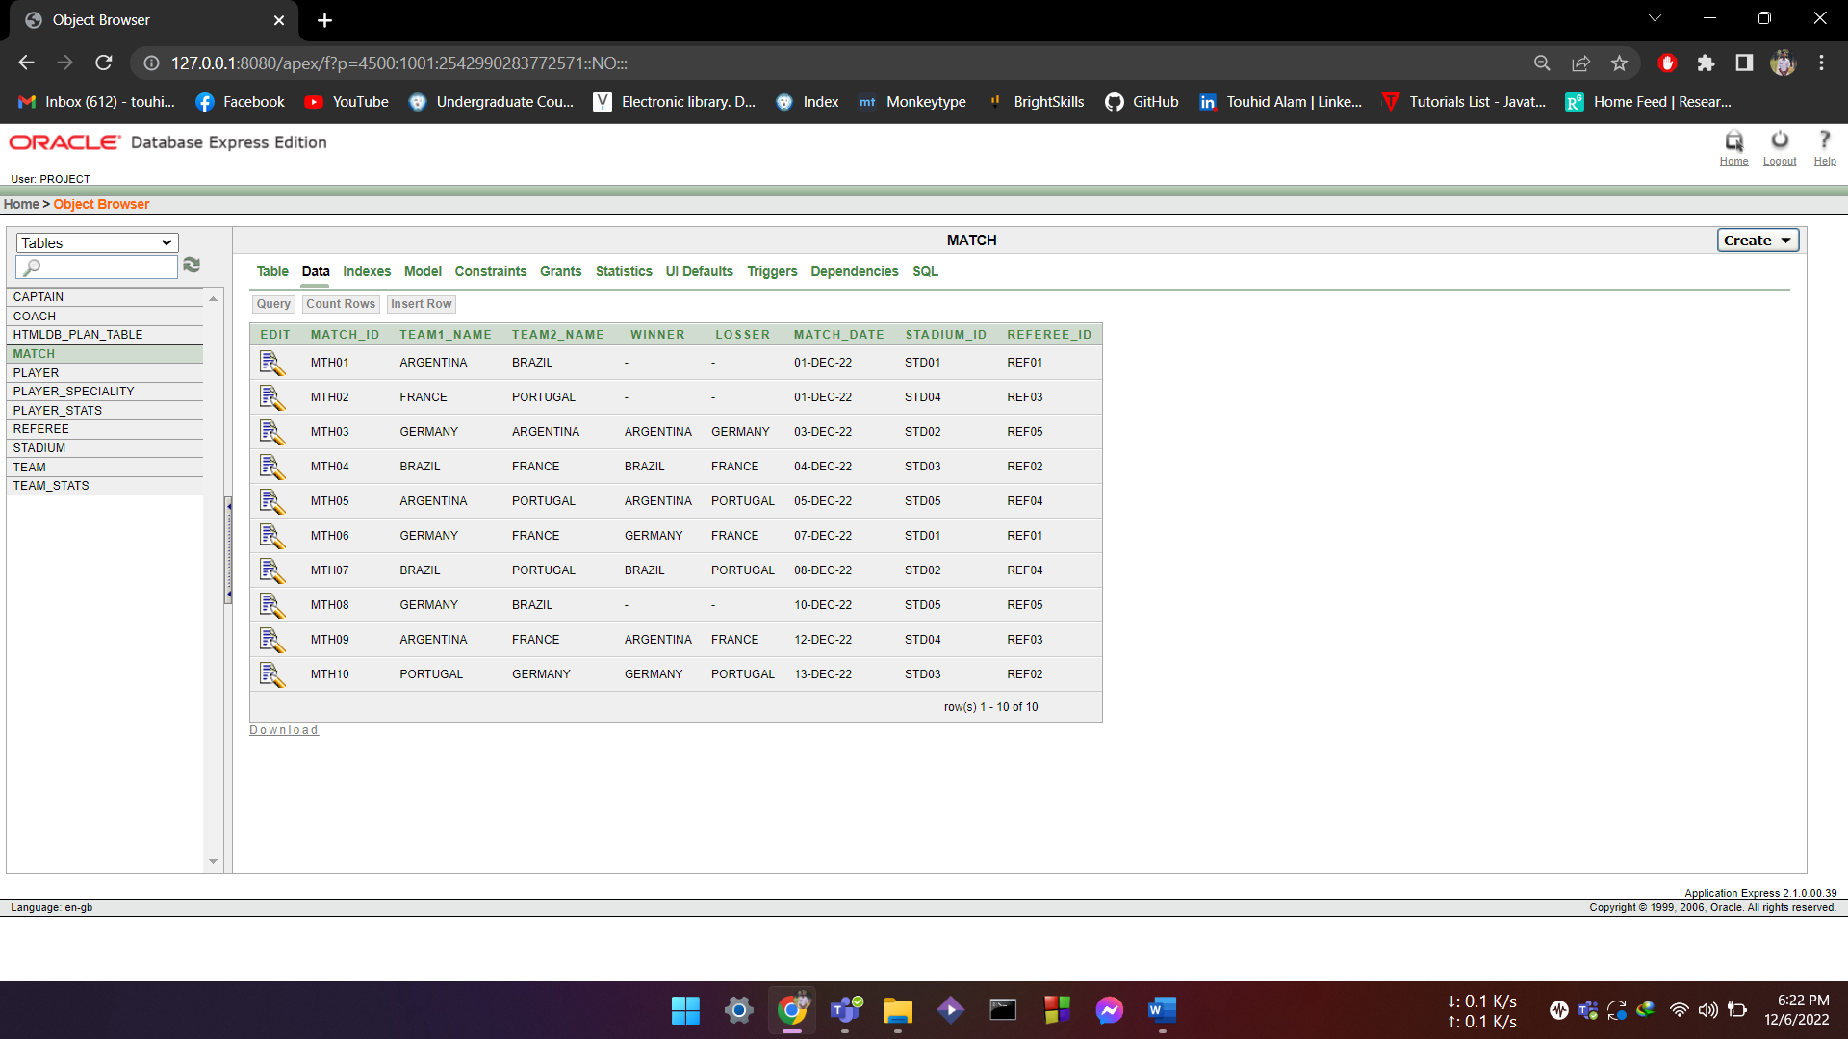

**QUERY DESIGN:**

**Function:**

* Write a query to show match details with no winners

select * from match where winner is null and losser is null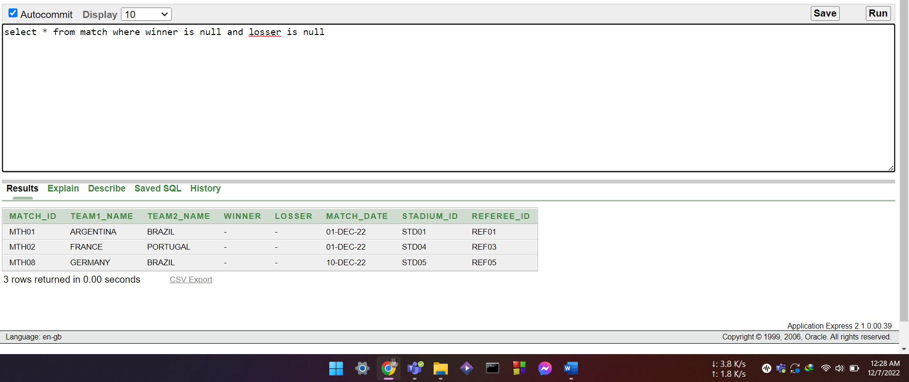

* Write a query to show the maximum capacity of stadium as MAX CAPACITY

SELECT MAX(CAPACITY) AS "MAXIMUM CAPACITY" FROM STADIUM;

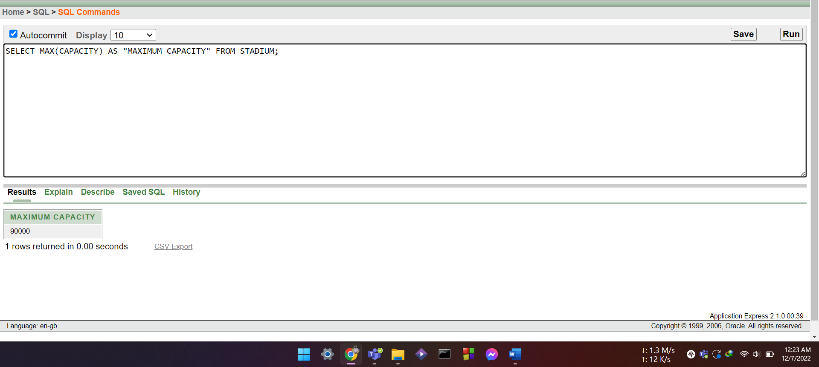

**Subquery:**

**Single row:**

* Write a query to show the players who scored more than average goals scored.

select player_id, goals from player_stats where goals>(select avg(goals) from player_stats);

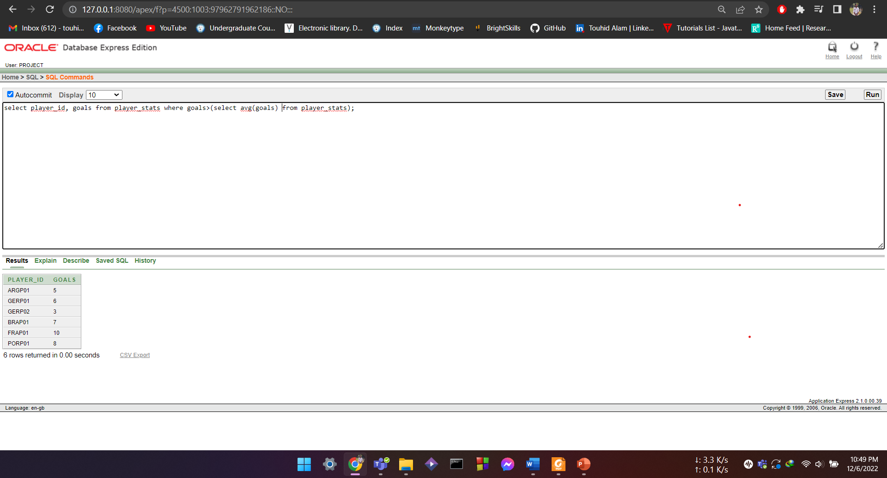

* Write a quey to show the details of most aged aged player.

select * from player where age=(select max(age) from player);

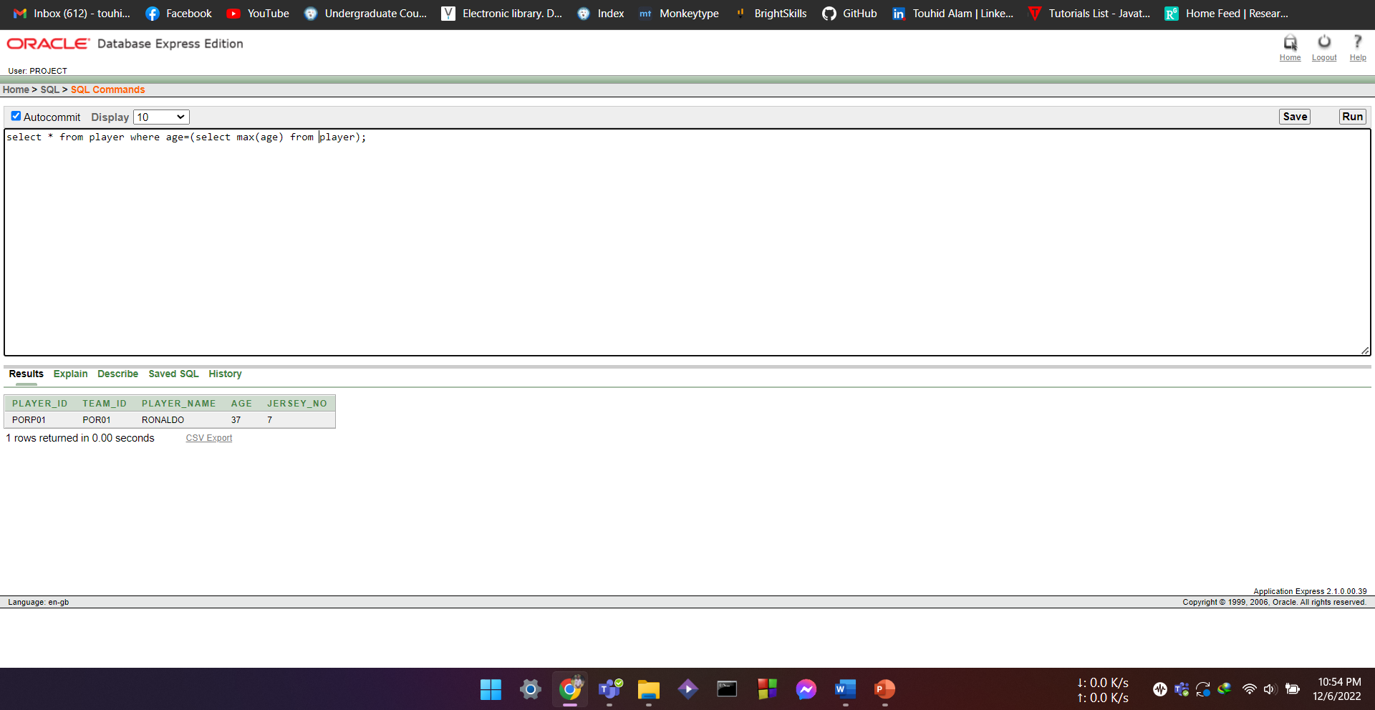

**Multiple row:**

* Write a query to display information of player who scored less than 5 goals;

select * from player where player_id in(select player_id from player_stats where goals<5);

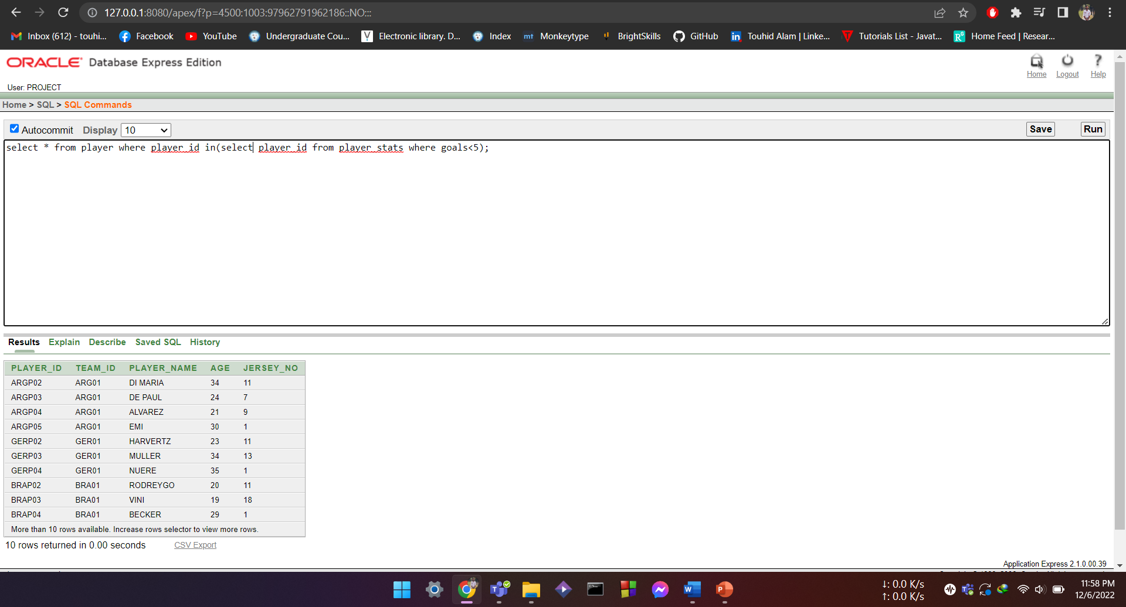

* Write a query to display the team information who lost more than one match

select * from team where team_id in(select team_id from team_stats where loss>1);

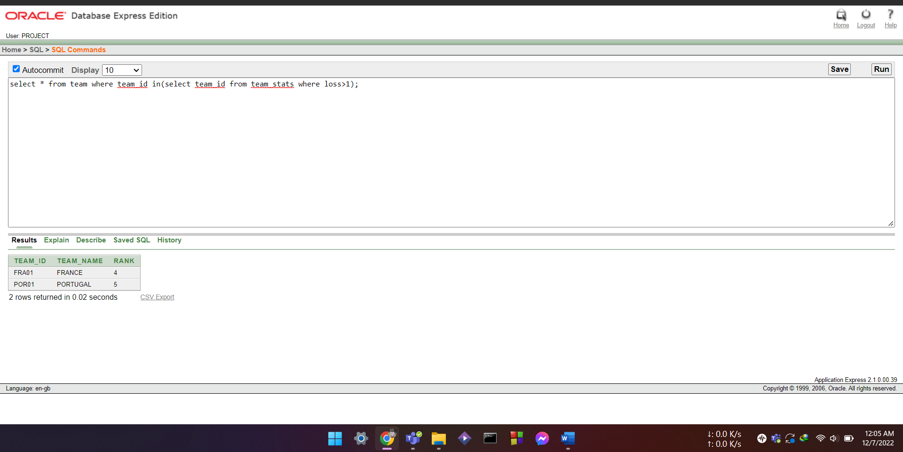

**Joining:**

**Equi-joining:**

* Write a query to show the captain name, captain id and team name;

select player.player_name, captain.player_id ,team.team_name from team,captain, player where player.player_id=captain.player_id and player.team_id=team.team_id;

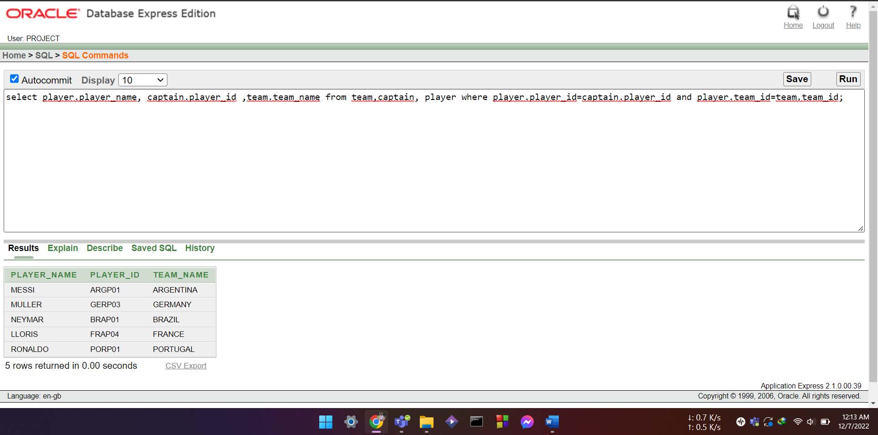

Outer-joining:

* Write a query to show the name of coaches and referee older than the coaches